Ideation Phase
Define the Problem Statements

Date | 22 June 2026
Team ID | 23A51A05M8
Project Name | Leave Approval System
Maximum Marks | 2 Marks

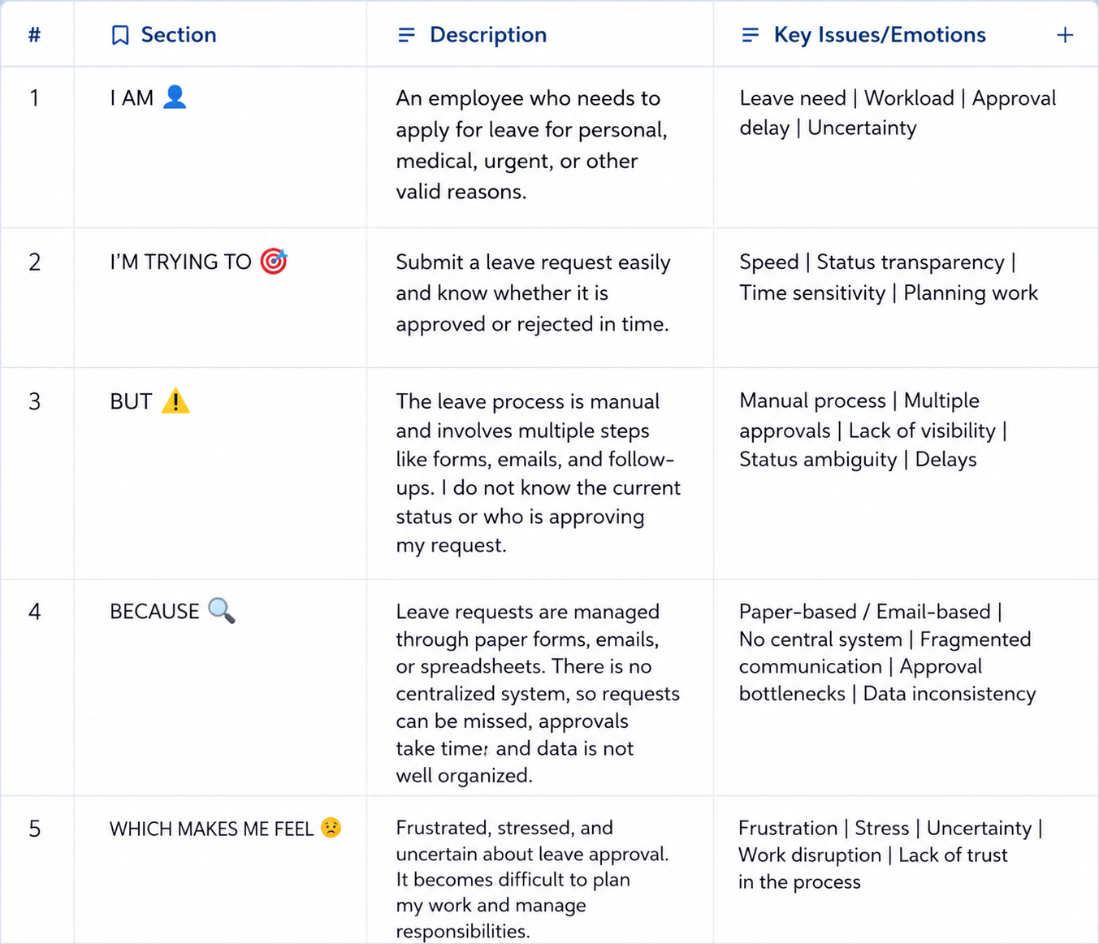
Reference: https://miro.com/templates/customer-problem-statement/
Problem Statement (PS) | I am (Customer) | I’m trying to | But | Because | Which makes me feel
PS-1 | Employee | Submit a leave request quickly and track its approval status. | The manual leave process is slow and difficult to monitor. | It requires paperwork or multiple email communications, and approvals may be delayed. | Frustrated, Uncertain, and Stressed.
PS-2 | Manager / Approver | Review and approve employee leave requests efficiently. | Managing multiple leave requests manually takes time and increases the chance of errors. | Leave requests come from different employees and need proper verification before approval. | Overloaded, Delayed, and Less Productive.

